

**ANALYTICS AND BUSINESS INTELLIGENCE** **PERSONAL LEARNING RECORD**

Student number:

Modul title: **ANALYTICS AND BUSINESS INTELLIGENCE**

Modul tutor:

Word count: **2061 words**

Table of Contents

Table of Figures 3

Introduction 4

Objectives 4

Methodology 4

Data Science and Modern-Day Organizations 5

Data Management 7

Numbers as ways of understanding the world and word problems 8

Organisation data consumption and data visualisation in Python 8

Data interpretation and visualisation in Tableau 9

Conclusion 9

Bibliography 10

APPENDIX A Data Management 11

1. Sort 11

2. Filter 13

3. Conditional Formatting 14

4. Charts 15

5. Pivot tables 16

6. Tables 16

7. What-If Analysis 17

8. Solver 18

9. Analysis ToolPak 20

APPENDIX B Numbers as ways of understanding the world and word problems 22

Mean 22

Median 23

Mode 23

APPENDIX C Organization data consumption and data visualization in Python 25

APPENDIX D Data interpretation and visualization in Tableau 29

# Table of Figures

Figure 1 Sort 11

Figure 2 Sort Result 11

Figure 3 Sort 2 11

Figure 4 Sort Result 2 12

Figure 5 Filter 12

Figure 6 Filter 2 13

Figure 7 Conditional Formatting 13

Figure 8 Conditional Formatting 2 14

Figure 9 Bar Chart 14

Figure 10 Doughnut Chart 15

Figure 11 Pivot Tables 15

Figure 12 Tables 16

Figure 13 Tables 2 16

Figure 14 Goal Seek 17

Figure 15 Goal Seek Result 17

Figure 16 Solver 18

Figure 17 Solver Parameters 18

Figure 18 Solver Result 19

Figure 19 Analysis ToolPak 19

Figure 20 Mean Formula 21

Figure 21 Mean 21

Figure 22 Median 22

Figure 23 Mode 22

Figure 24 Geometric visualization of the mode, median and mean of an arbitrary probability density function 23

Figure 25 Summary Statistics and Data Preparation 24

Figure 26 Code for Data Visualization (Attack Value Histogram) 24

Figure 27 Histogram of Pokemon Attack 25

Figure 28 Code to check for outliers 25

Figure 29 Group by 26

Figure 30 Mean, Median, Standard deviation in Python 26

Figure 31 Pivot Table 27

Figure 32 Code for Mental Health Bar Chart 27

Figure 33 Mental Health Bar Chart 28

Figure 34 Map 29

Figure 35 Creating a groups 29

Figure 36 Default Number Format 30

Figure 37 Calculated Field 30

Figure 38 Weekly Mobility Line Chart 31

Figure 39 Monthly Mobility Line Chart 31

Figure 40 Selecting proper colours 32

Figure 41 Map 2 32

Figure 42 Map of Europe 33

Figure 43 Residential Change Horizontal Bars 33

Figure 44 Residential Change Side by Side Bar Chart 34

# **Introduction**

In the face of the constantly advancing civilization development and the accompanying progress the role of information is constantly increasing in the technological world. Access to it determines the civilization advancement of entire societies as well as, determines the standard of living of individuals. In the educational sphere information affects the level of education and opens opportunities for self-improvement. The importance of access to data has long been noticed and used commercially by specialized companies. Not without a reason it is said that data is a new oil, but just like an unrefined oil, unprocessed data does not really have any value.(Mayer-Schönberger & Cukier, 2013). The average user of the Internet often is not aware that the result of his search is the result of a complex data processing process. The user doesn't think about how the information was extracted from the rest stored in the database, nor does he care what position it occupies in its structure or what the information flow in the database looks like. Often, the user is unaware that is using the database at all. (Dwyer, 2013)

# **Objectives**

The objective of this assignment is to analyze and explain data using various tools and techniques in a different environment. Throughout the course, programs such as Excel, Python, and Tableau have been utilized to facilitate data analysis. This assignment aims to demonstrate the understanding and application of these tools by utilizing different type of data sets. By analyzing these datasets, the aim is to extract valuable insights and effectively manipulate and interpret data to extract meaningful information and communicate it effectively. This assignment will also showcase the skills and proficiency in using tools such as Excel, Python, and Tableau for data analysis.

# **Methodology**

To achieve the objectives of this assignment, the following steps will be taken:

1. Obtain different type data sets.
2. Clean and preprocess the data as necessary, including checking for missing values and formatting the data appropriately.
3. Explore the data using various tools and techniques, such as Excel, Python, and Tableau.
4. Analyze the data to extract meaningful insights and identify trends and patterns.
5. Communicate the findings and results through the creation of visualizations, reports, and presentations.
6. Reflect on the learning process and document any challenges or lessons learned.

# **Data Science and Modern-Day Organizations**

**Who is a statistician, Data analyst and Business Analyst?**

In first week, we have learned about the various roles and responsibilities of professionals working in the field of data science and modern-day organizations. We have learned that statisticians are professionals who use statistical methods and techniques to analyze data and solve real-world problems. They may work in a variety of fields, including research, business, government, and healthcare, and may be involved in tasks such as collecting and analyzing data, developing statistical models, and interpreting and communicating results(Salkind, 2013)

Data analysts are professionals who use data to provide insights and inform decision-making within a business or organization. They may be responsible for tasks such as collecting and cleaning data, creating reports and visualizations, and identifying trends and patterns in data.

Business analysts are professionals who help organizations improve their processes and operations by identifying problems and proposing solutions based on data and analysis. They may be involved in tasks such as conducting market research, analyzing financial data, and developing business strategies.

**Using the Web and online tools, identify the necessary skills required for becoming a data scientist.**

To become a data scientist, you should have a strong foundation in math, statistics, and computer science, and be proficient in programming, statistics and machine learning, data visualization, data cleaning and manipulation, data storage and management, and communication and teamwork. It is useful to be proficient in a programming language such as Python, R, Java, or C++, and be familiar with tools such as Tableau, D3.js, and ggplot for data visualization. Data scientists should also be able to manipulate and clean data, access data from databases, and choose appropriate storage solutions for different types of data. They should be able to effectively communicate their findings to both technical and non-technical audiences and work well in a team.

**How can you position yourself for any of these job roles?**

I am a former student of Computing with a strong interest in data analysis. I have a good understanding of programming languages such as Python and have experience working with data analysis tools such as Excel, Tableau and Python. I have also gained basic knowledge of databases such as SQL and MongoDB. In addition to my technical skills, I possess strong soft skills such as teamwork, great communication, problem-solving, and adaptability, which are all valuable assets in a data science career. am motivated to use my skills and knowledge to make a positive impact through data-driven insights and solutions in various industries.

**State and discuss the requirements of an organization before hiring a data scientist for example, access or availability of large amount of data.**

Before hiring a data scientist, an organization should consider factors such as access to data, the data scientist's skills and experience, their ability to work effectively with cross-functional teams, and their ability to communicate complex data-driven insights clearly. In addition, the organization should have the necessary infrastructure and resources in place to manage and process large amounts of data.

**What is Business Intelligence BI?**

Business intelligence refers to the tools, systems, and processes that organizations use to collect, store, and analyze data. BI's primary goal is to assist managers in their decision-making(Éric Foley, 2010)*.* It can include a range of technologies and techniques such as data mining, data visualization, reporting, and dashboarding, as well as the use of tools such as spreadsheets, databases, and data warehousing.

**Of what benefits is business intelligence to any organization?**

Business intelligence is used to turn raw data into information that may be used for commercial reasons. BI can be utilized in fields including finance, marketing. Businesses may become more efficient and competitive, improve strategic planning, boost customer happiness, manage risks, and become more agile with the aid of business intelligence (BI). In general, BI may assist businesses in making better use of their data assets to generate revenue and accomplish their objectives.

**State at least 3 job roles available in the areas of business intelligence indicating the skills, starting salary, maximum salary, and other job benefits**

There are several job roles available in the field of BI, including business intelligence analyst, data scientist, and business intelligence developer. These roles typically require skills such as programming, data analysis, data visualization, data storage and management, communication, and teamwork, and problem-solving. Depending on the role, additional skills such as machine learning and domain expertise may also be required. According to Indeed in the UK, the average salary for a business intelligence analyst is around £40,000 per year, the average salary for a data scientist is around £45,000 per year, and the average salary for a business intelligence developer is around £50,000 per year. Some potential job benefits for these roles could include training and development opportunities, flexible working hours, the opportunity to work with cutting-edge technology, and access to a highly collaborative and dynamic work environment. (Indeed, 2023)

**Compare and contrast the characteristics of the identified job roles and present a statement of conclusion.**

The job roles of business intelligence analyst, data scientist, and business intelligence developer all involve working with data to inform decision-making within an organization. However, there are some key differences between these roles:

* Business intelligence analysts focus on collecting and analyzing data, as well as creating reports and visualizations to help managers understand trends and patterns. They may also be involved in identifying problems and proposing solutions based on data.
* Data scientists use data to extract insights and inform decision-making. They may be involved in tasks such as collecting and cleaning data, developing statistical models, and using machine learning algorithms to analyze data.
* Business intelligence developers design and build systems and processes to enable organizations to collect, store, and analyze data. They may be involved in tasks such as developing databases, creating dashboards and reports, and implementing data storage and management systems.

In summary, business intelligence analysts focus on data analysis and visualization, data scientists focus on extracting insights and using statistical and machine learning techniques, and business intelligence developers focus on building systems and processes to enable data collection, storage, and analysis.

# Data Management

Data management is the process of organizing, storing, and maintaining the data of an organization. This includes tasks such as data creation, access, and updating, as well as policies, procedures, and best practices for ensuring data security, accuracy, and availability.

I will demonstrate my knowledge of the following aspects:

1. Sort
2. Filter
3. Conditional Formatting
4. Charts
5. Pivot Tables
6. Tables
7. What-If Analysis
8. Solver
9. Analysis ToolPak

# Numbers as ways of understanding the world and word problems

Analytic number theory is a field of number theory in mathematics that applies techniques from mathematical analysis to issues involving integers.(Apostol, 1976, p. 7)

One of the key elements of number theory that is particularly relevant to analytics is the concept of prime numbers. These integers are divisible only by themselves and 1, and they form the building blocks of all other numbers. As such, understanding the properties and behaviour of prime numbers can aid in understanding the properties of other numbers, and they are often used in encryption and data compression. Another fundamental concept in number theory that is relevant to analytics is modular arithmetic. This system of arithmetic operates under the principle that all numbers "wrap around" after a certain value, known as the modulus. This concept finds application in a variety of areas within analytics such as time series analysis, data hashing and representing cyclical data. Furthermore, number theory provides various number-theoretic functions, such as the greatest common divisor (GCD) and the least common multiple (LCM), which are utilized in the field of analytics to analyse the relationship between different variables. These functions can aid in identifying patterns in cyclical data, such as financial or weather data. In addition, number theory also encompasses various number-theoretic algorithms, such as the Euclidean algorithm and the Sieve of Eratosthenes, which are used in analytics to perform complex computations and to filter data.(Tenenbaum, 1995, p. 56)

# Organisation data consumption and data visualisation in Python

Organizational data utilization involves harnessing the power of data within an organization to make informed decisions, optimize processes, and gain valuable insights. Research indicates that, on average, a small fraction of an organization's structured data is actively utilized in decision-making, with even less of its unstructured data being analysed or employed (Leandro DalleMule, 2017)*.* This implies that many organizations may not be effectively utilizing all the data at their disposal.

# Data interpretation and visualisation in Tableau

Data visualization is the process of using graphical representations to make complex data relationships and insights more comprehensible. This can be achieved by various analytical and visualization tools and techniques. One specific example of this is in the field of population health and health services research, where visualization tools are used to analyse and present data to identify patterns, trends, and outliers in large data sets. (Jawad Ahmed Chishtie, 2020)*.* This can help researchers and practitioners better understand the data they are working with and make more informed decisions.

# Conclusion

In conclusion, the study and practice of Analysis and Business Intelligence has greatly enhanced my understanding of the vast and dynamic field of data science. Through the preparation of this report, which demonstrates the use of graphic models and functions to analyze different data sets, I have been able to appreciate the powerful capabilities of these analysis programs. These programs are capable of easily interpreting databases, making them useful for a wide range of fields and activities. The programs contain many features and built-in functions, and the choice of tools will depend on the specific task and intended audience. Excel and Tableau are well-suited for visualization, while Python is more commonly used for statistical analysis and forecasting. The report has also reinforced the importance of understanding the underlying theory and context to effectively utilize data. Overall, the study and practice of Analysis and Business Intelligence has provided me with a comprehensive understanding of the dynamic field of data analysis and the importance of understanding the context of data.

# Bibliography

Éric Foley, M. G. G., 2010. International Journal of Business Intelligence Research. p. 28.

Apostol, T. M., 1976. *Introduction to analytic number theory.* New York-Heidelberg: Springer-Verlag.

Dwyer, T. H. W. &. K.-H. A., 2013. Understanding the black box: How users interpret search engine results and the factors that influence their interpretation. Information Processing & Management. *Information Processing & Management ,* pp. 13-24.

Indeed, 2023. *Indeed.* [Online]   
Available at: https://uk.indeed.com/career/business-intelligence-developer/salaries

Jawad Ahmed Chishtie, J.-S. M. L. A. T. I. A. B. J. B. M. C.-M. M. I. S. M. S. A. M. B. S. H. M. I. T. J. S. J., 2020. Visual Analytic Tools and Techniques in Population Health and Health Services Research. *Journal of Medical Internet Research.*

Leandro DalleMule, T. H. D., 2017. *Harvard Business Review.* [Online]   
Available at: https://hbr.org/2017/05/whats-your-data-strategy

Mayer-Schönberger, V. & Cukier, K., 2013. *Big Data: A Revolution That Will Transform How We Live, Work, and Think.* Boston, Massachusetts: Houghton Mifflin Harcourt.

Salkind, N. J., 2013. *Statistics for People Who (Think They) Hate Statistics.* Los Angeles: CA: SAGE..

Tenenbaum, G., 1995. *Introduction to Analytic and Probabilistic Number Theory, Cambridge studies in advanced mathematics.* Cambridge: Cambridge University Press.

# APPENDIX A Data Management

## Sort

The SORT function in Excel is used to sort a range of cells alphabetically or numerically. It allows to organize data in a specific order. I used a sort function here to sort the Fast-Food Restaurant names alphabetically, which shows the most common ones and is easier to navigate. The pictures show how I used this function and the final result.

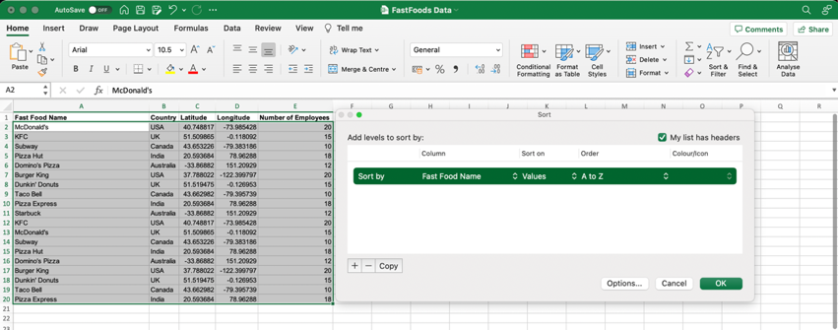

Figure 1 Sort

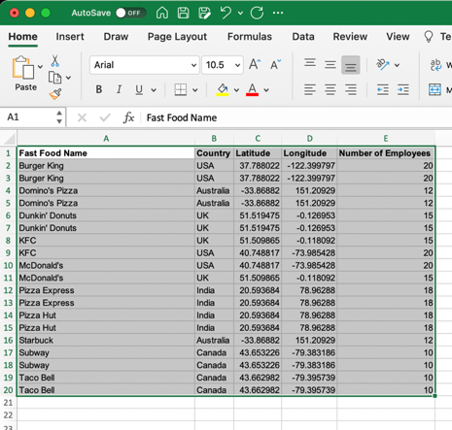

Figure 2 Sort Result

Here, I sorted data based on its Latitude from smallest to largest.

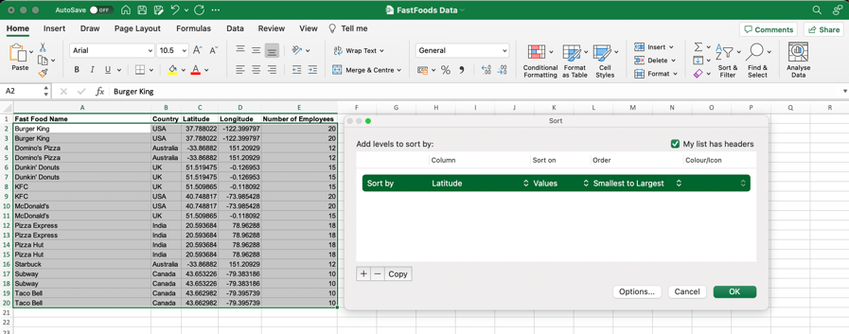

Figure 3 Sort 2

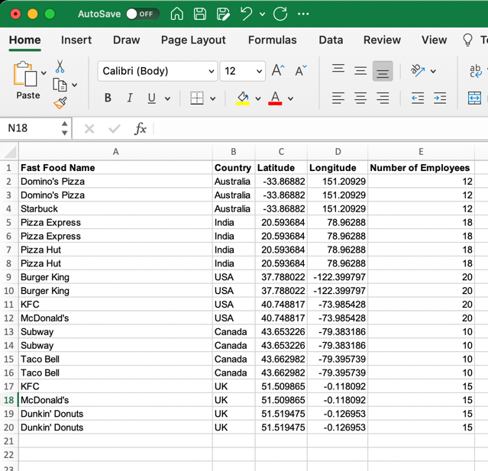

Figure 4 Sort Result 2

## Filter

The FILTER function in Excel is a powerful tool that allows to extract a subset of data from a larger dataset based on specific criteria.

It returns a filtered version of a range of data, based on the conditions specified in the formula.

I filtered my data set based on country. I wanted to have a Restaurants located in UK only.

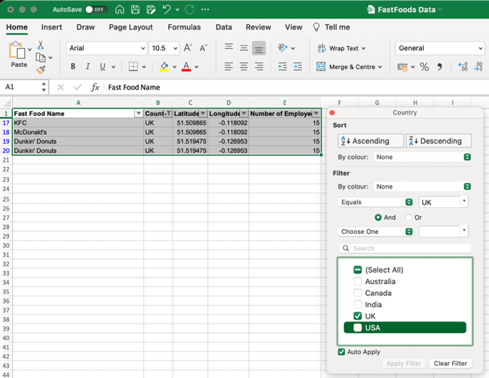

Figure 5 Filter

I filtered my data set by value. In the result I have restaurants with 18 or more employees.

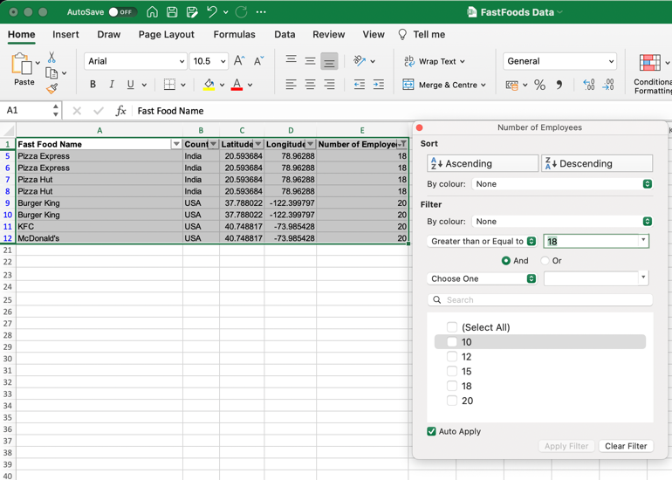

Figure 6 Filter 2

## Conditional Formatting

Conditional formatting in Excel allows to apply formatting to cells based on certain conditions. I formatted cells using color scales with the number of employees in green if the number is between 10 and 15, in yellow if it's between 15 and 20 and in red if it's greater than 20.

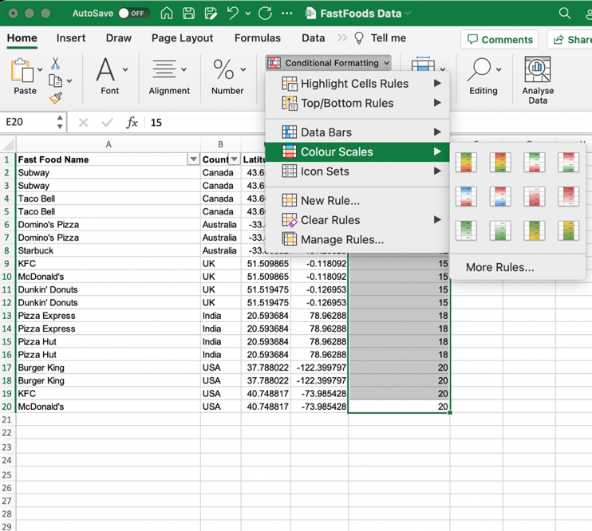

Figure 7 Conditional Formatting

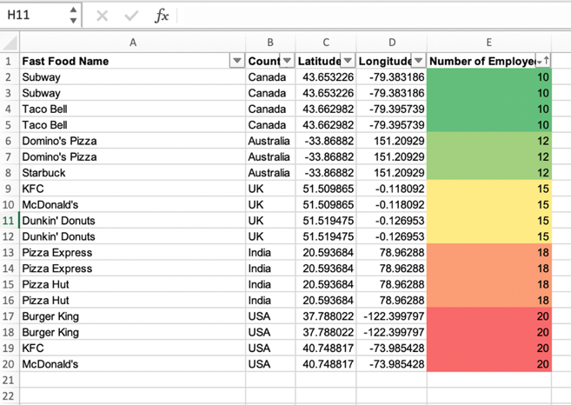

Figure 8 Conditional Formatting 2

## Charts

This chart is a bar chart and is demonstrating a total spending in each restaurant as well as a linear trendline which shows that a trend in spending is around £8. I added data labels to have a better visualization of data.

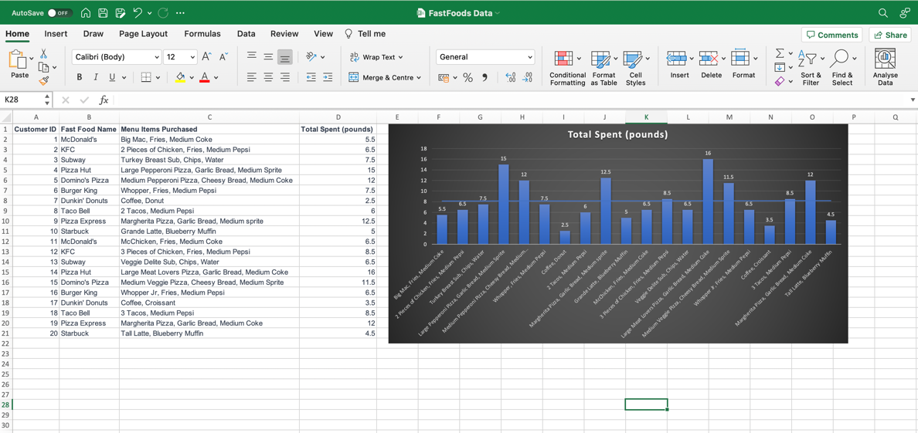

Figure 9 Bar Chart

To generate this chart, I created a new row called Total Spent by Restaurant. I filtered restaurants to leave only places that sells pizza, and I used SUM IF formula to sum up the spending from the same restaurants. For this visualization I used doughnut chart as I believe it demonstrates these values the best. We can observe that customers spent the most money in Pizza Hut Restaurant.

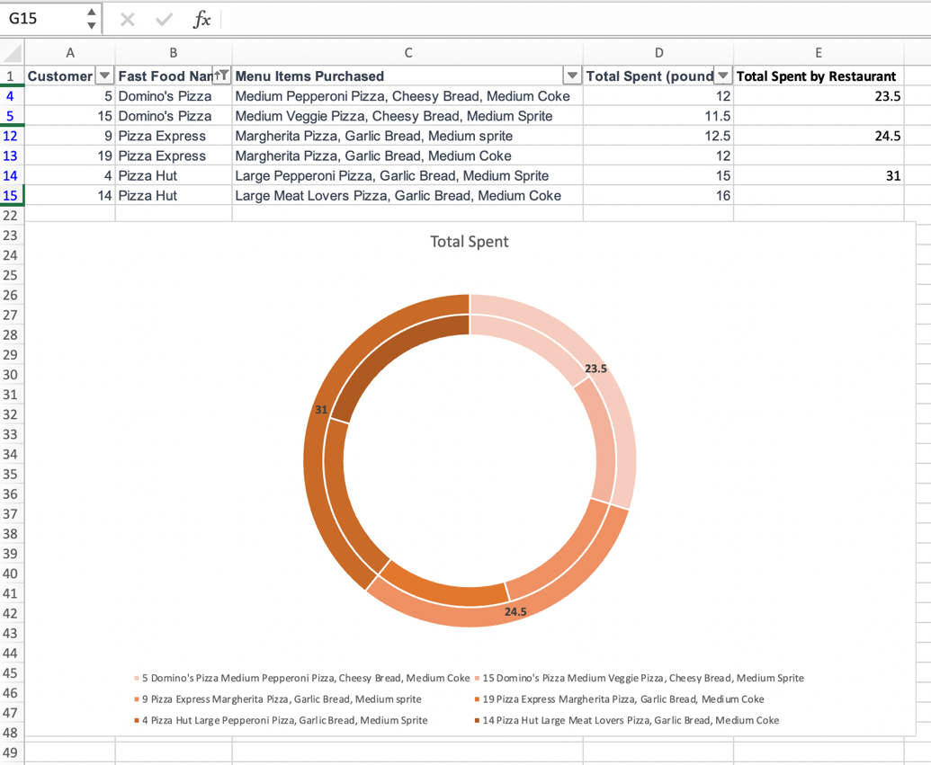

Figure 10 Doughnut Chart

## Pivot tables

This pivot table provides a breakdown of total sales by menu item and state, giving me a better understanding of which menu items are popular in which states and helping to make informed business decisions.

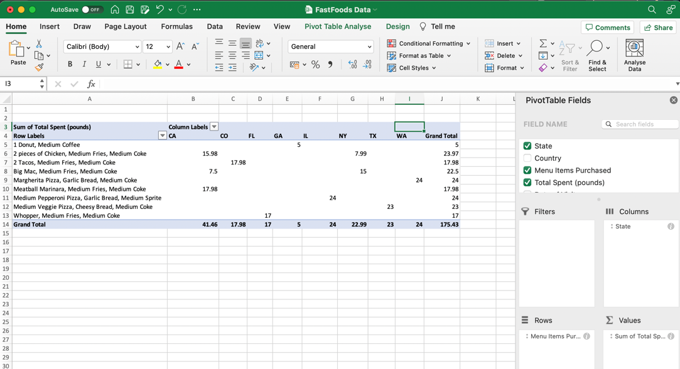

Figure 11 Pivot Tables

## Tables

In Excel, a table is a range of cells that is organized into columns and rows, and is designed to make it easier to manage and analyze large amounts of data. Tables in Excel have several built-in features that make it easier to work with data, such as automatic formatting, structured references, sorting, filtering, dynamic data, and data validation. I created a table and demonstrated structured references feature, which provide a way to refer to the data in a table by using the table name and column names, which makes the formulas more understandable and less prone to errors. First, I changed the table name.

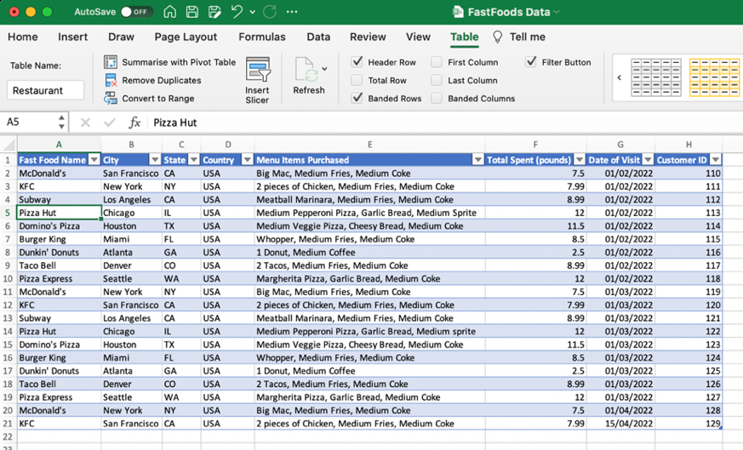

Figure 12 Tables

Then, I used it quickly calculate the number of rows and columns using formula.

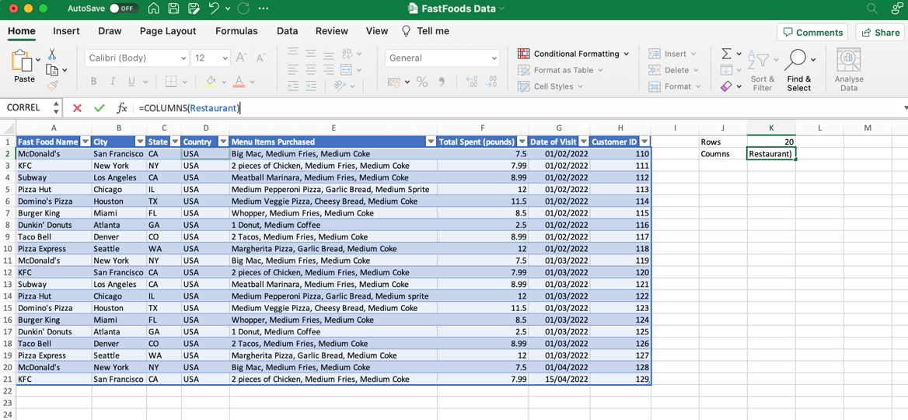

Figure 13 Tables 2

## What-If Analysis

What-if in Excel is a tool that allows you to explore different scenarios by changing variables and seeing the outcome. It includes Goal Seek and Scenario Manager which enable you to find the input values that will give you a specific result and to create, compare, and apply different scenarios. This can help in decision making by providing the potential outcomes of different scenarios.

I wanted to find out how many McSpicy Mc Donald’s would have to sell a day to achieve a goal of £800 pounds. I used a Goal Seek to demonstrate it. The Goal Seek works only with the cells that contains a formula. I used a standard formula for a Revenue.

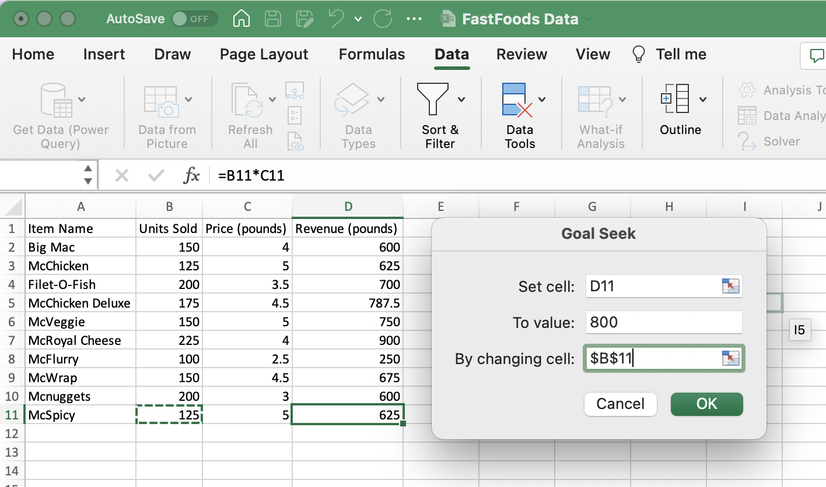

Figure 14 Goal Seek

In the result we can observe increase of units sold from 125 to 160 which give us an idea how much we need to increase our sells without changing a price.

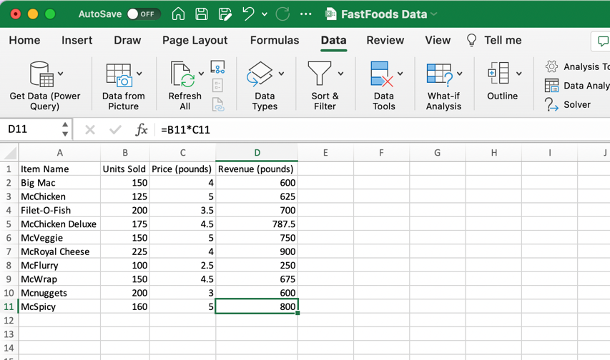

Figure 15 Goal Seek Result

## Solver

Solver allows users to find the optimal solution to a problem that has multiple possible inputs or variables. It uses mathematical algorithms to find the best combination of inputs that meet certain criteria, such as maximizing profits or minimizing costs. It can be used for various types of optimization problems, including linear and nonlinear programming. I used solver to define what score student would have to achieve from two not marked modules to get a 90% score as a total.

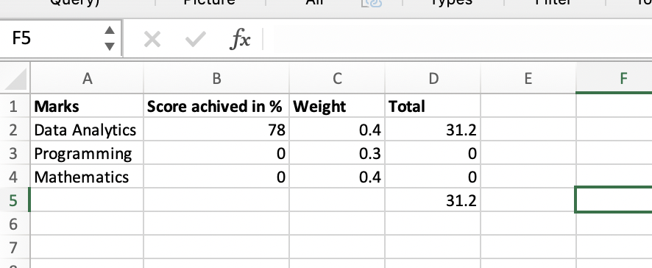

Figure 16 Solver

I set objective to value of 90 as well as added total score from these two modules can be less or equal to 100.

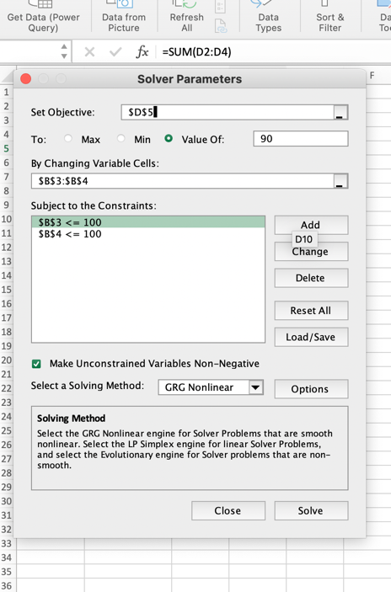

Figure 17 Solver Parameters

The student would have to achieve at least 70% in Programming and 94% in Mathematics to score 90% at the end of the semester.

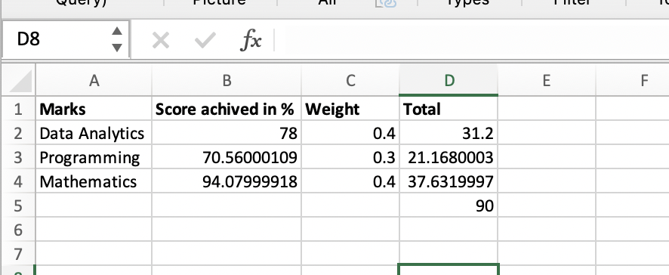

Figure 18 Solver Result

## Analysis ToolPak

An Analysis ToolPak is a collection of data analysis tools for more advanced statistical and engineering analysis. It includes tools such as histograms, corelation, t-tests, and Fourier analysis. For this task I used a Migration Flows Data from Kaggle. The analysis is made on GP registrations and international inflows in mid 2010-2011 in traditional regions of England (North East, North West, Yorkshire and The Humber, East Midlands, West Midlands, East London, South East, South West.)

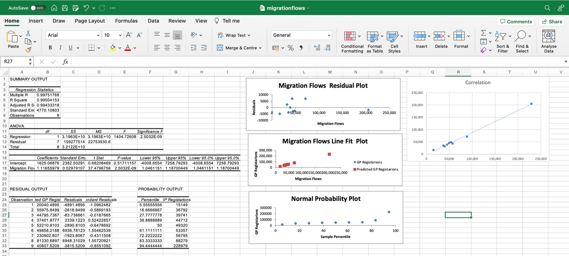

Figure 19 Analysis ToolPak

**Coefficient of determination**

It tells how much variance the dependent variable can be accounted for by the independent variable. In this case R square is approximately equal to 0.99, which means that 99% of the variance in GP registrations can be accounted by the international inflows.

**Standard error**

Standard error equals to 4770. It is the average distance that the observed values fall from the regression line.

**Observations**

Observations equals to 9. It is the number of subjects or data points in the test. I my case it is the eight regions of England.

**Correlation**

We can observe very strong positive correlation between GP Registrations and International Inflows. The line is upward slopping and values are accumulated on the line. If the line would be downward slopping, we could say that this is negative correlation. From the prediction perspective it is not essential to specify if the correlation is positive or negative. The closer the result is to one or negative one, the better the quality of prediction is going to be.

**Y-intercept:**

This is a point where the line of best fit or regression line crosses the y axis when the value of x is 0. The second row displays the results for the slope. The most basic version of the equation is Y = m*X+b where Y is the predicted value of the dependent variable (GP registrations in this example), m is the slope of the line of the best fit, x is the value of the independent variable (migration inflows in this example)

Predicted Y value is 1.116559795 * X - 1625.06875634973

**P-value:**

To compute the p-value I am using alpha = 0.05. Decision rule is if my p-value is less than 0.05 than the correlation is statistically significant. Since 2.50 is bigger than 0.05 that indicates that the correlation is not in fact significant in this case.

# APPENDIX B Numbers as ways of understanding the world and word problems

## Mean

In statistics, the mean is a measure of central tendency, which is a way to describe the typical or average value of a set of data. The mean is calculated by adding up all the values in a data set and then dividing by the number of values. It is also known as the arithmetic mean or simply the average. The mean is a commonly used measure of central tendency and is often used to summarize a set of data and describe its overall pattern.

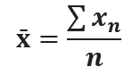

Figure 20 Mean Formula

Where:

x̄ is the sample average of variable x.

∑xn= sum of n values.

n = number of values in the sample.

I calculated Mean of the exam points with “Average” formula in Excel using students record data set.

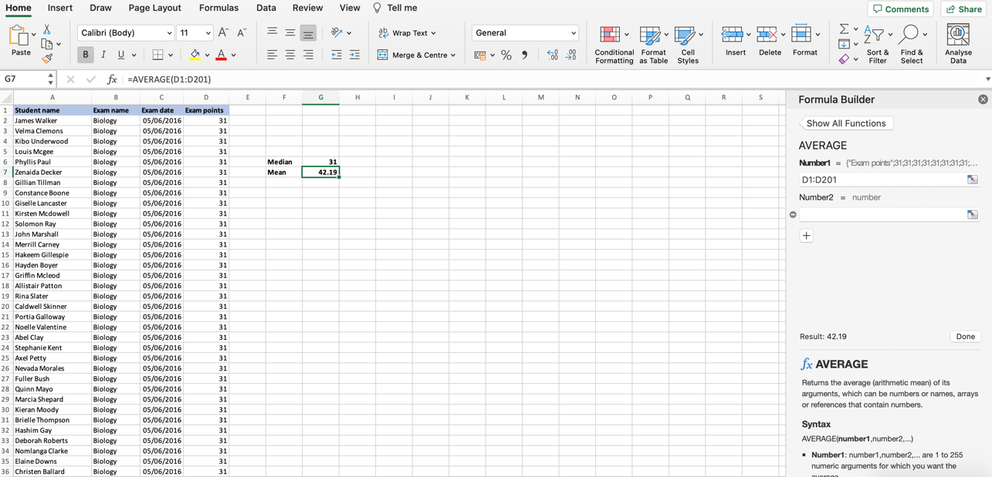

Figure 21 Mean

## Median

In statistics, the median is a measure of central tendency, which is a way to describe the typical or average value of a set of data. The median is the middle value when a data set is ordered from least to greatest. To find the median of a data set, you first need to order the data from least to greatest and then if the data set has an odd number of observations, the median is the middle value. If the data set has an even number of observations, the median is the average of the two middle values.

Using the same data set and Excel Insert function feature I calculated median of student’s exam points.

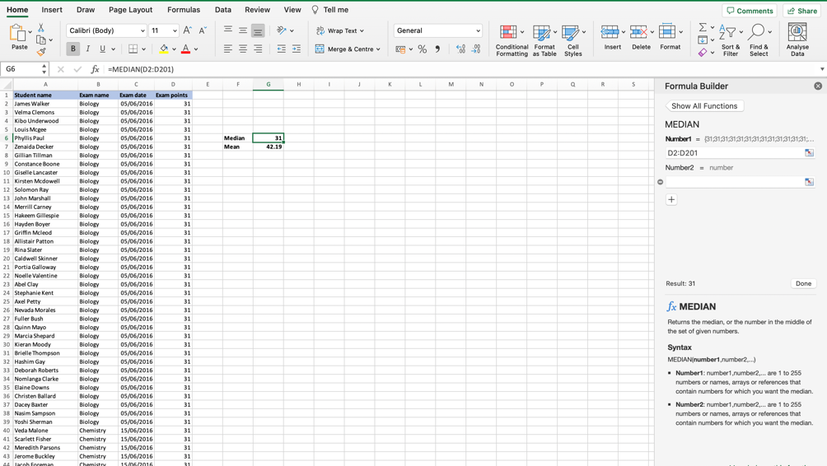

Figure 22 Median

## Mode

In statistics, the mode is a measure of central tendency, which is a way to describe the typical or most common value of a set of data. The mode is the value that appears most frequently in a data set. A data set can have one mode, more than one mode, or no mode at all. If a data set has two or more values that appear most frequently, it is called multimodal.

In this example the data set is unimodal, which means that has only one mode.

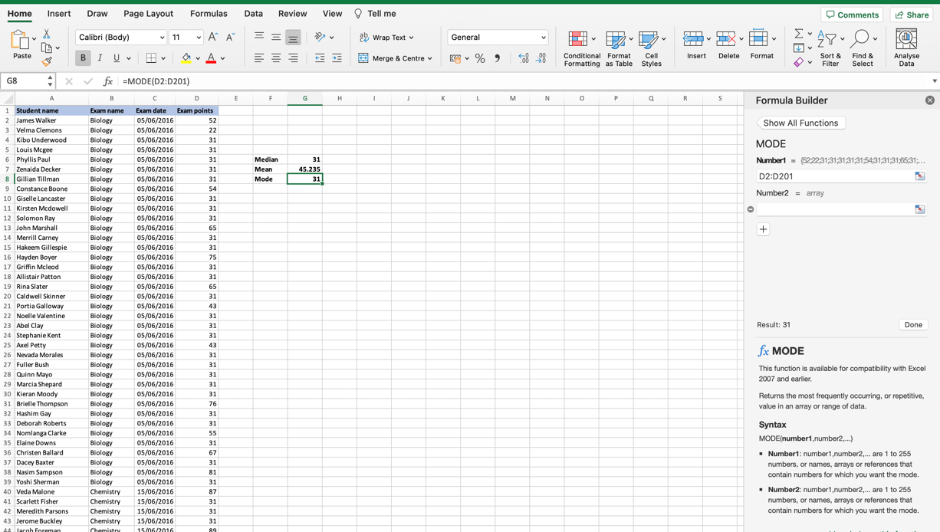

Figure 23 Mode

In summary, mean, median, and mode are all measures of central tendency that are used to describe the typical or average value of a set of data. Mean is sensitive to outliers, median is less sensitive to outliers, and mode is not affected by outliers and is more useful for categorical data.

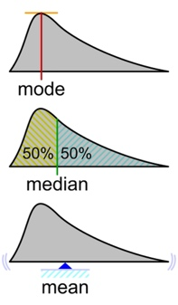

Figure 24 Geometric visualization of the mode, median and mean of an arbitrary probability density function

# APPENDIX C Organization data consumption and data visualization in Python

First, all necessary libraries must be imported. Pandas in this code is used for reading in the CSV file and accessing the data within it and numpy for numerical computations. In line 15 I am uploading a data set from my computer through a correct path. Next step is to check for missing values and to check the first few rows of the DataFrame to ensure that the data was loaded correctly (line 28) after that I calculate summary statistics for the numerical columns, in this output, it tells that there are 800 unique rows in the dataframe, and the top value is the first row. The frequency of the top value is 1.

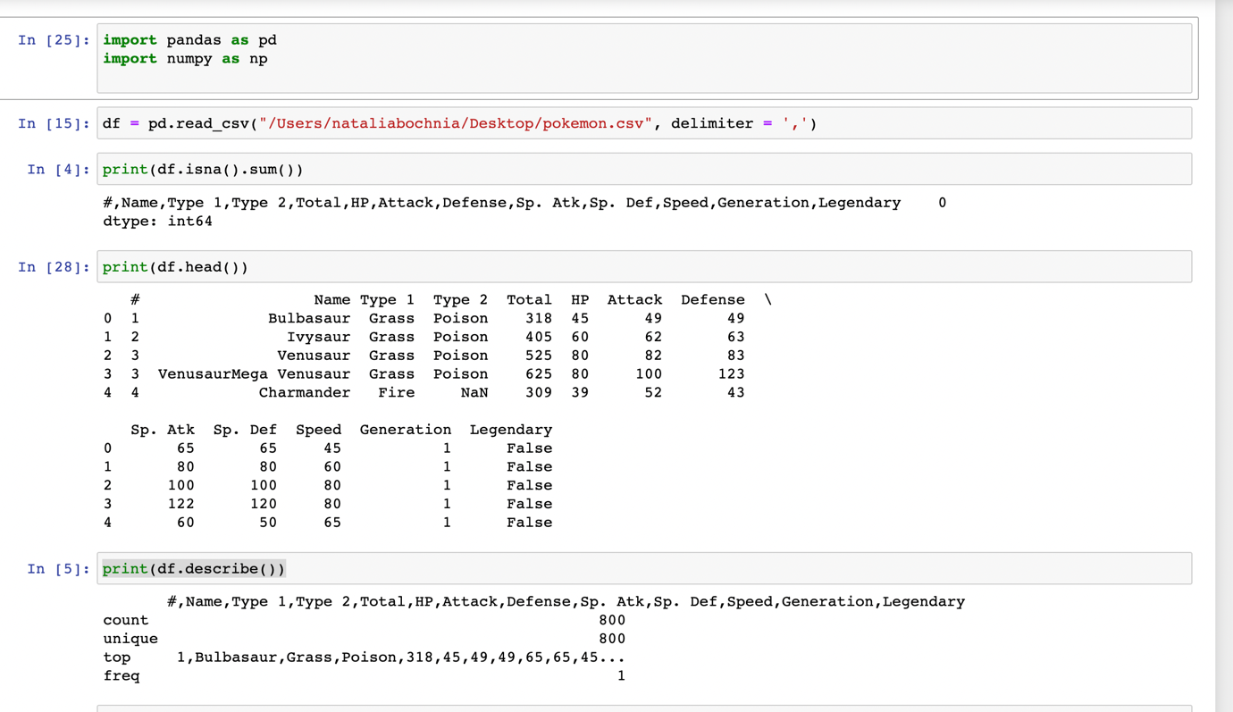

Figure 25 Summary Statistics and Data Preparation

Next I import matplotlib.pyplot for data visualization. In the code I provided, it is used to create a histogram of the Attack column of the dataframe.

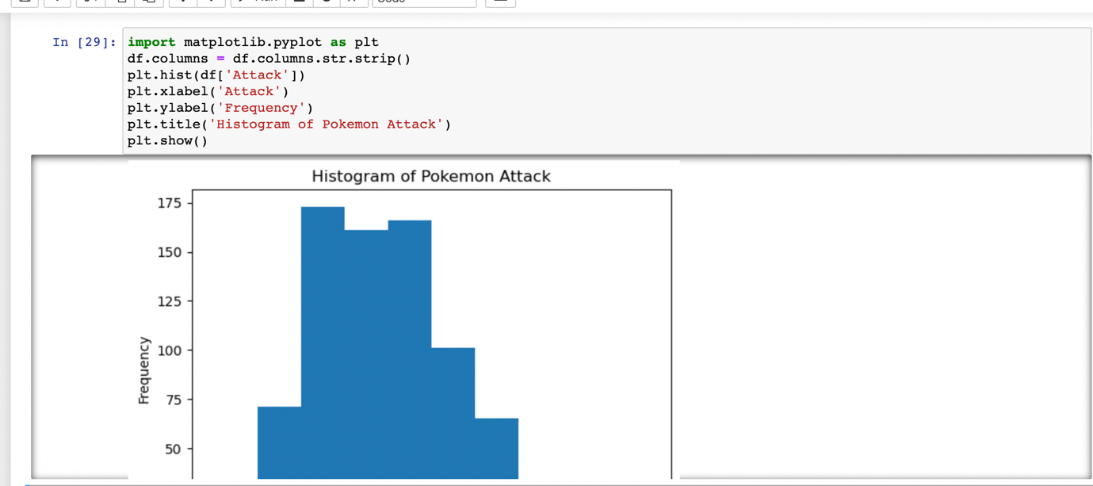

Figure 26 Code for Data Visualization (Attack Value Histogram)

In this case, the histogram shows the frequency of different attack values among all the Pokemon in the dataset. By looking at the histogram, we can see that the most common attack value is around 60, and the number of Pokemon with high attack values (above 100) is relatively low. This can give us an idea of the general distribution of attack values among the Pokemon.

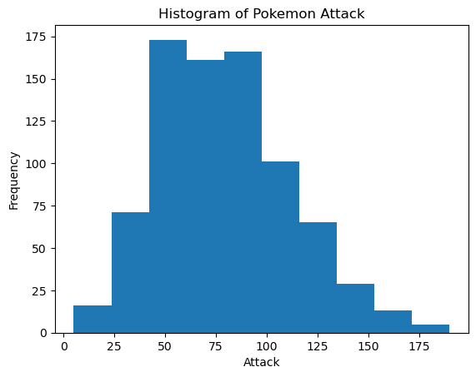

Figure 27 Histogram of Pokemon Attack

To check for outliers in a numerical dataset, one common method is to use the interquartile range (IQR). The IQR is the difference between the 75th percentile (Q3) and the 25th percentile (Q1) of the data. Outliers are defined as values that are more than 1.5 times the IQR below Q1 or above Q3. In this output, there are 7 rows that have an Attack value greater than or equal to 185. These rows are for following Pokemon: Mewtwo Mega, Mewtwo X, Heracross Mega, Heracross, Groudon Primal, Groudon, Rayquaza Mega, Rayquaza, Deoxys Attack Forme, Garchomp Mega, Garchomp, and Kyurem Black, Kyurem. It is important to note that whether these values are considered outliers or not depends on the context of the data and the specific use case. In this case, it is possible that these Pokemon are considered particularly strong in terms of Attack and therefore their high Attack values are not considered outliers.

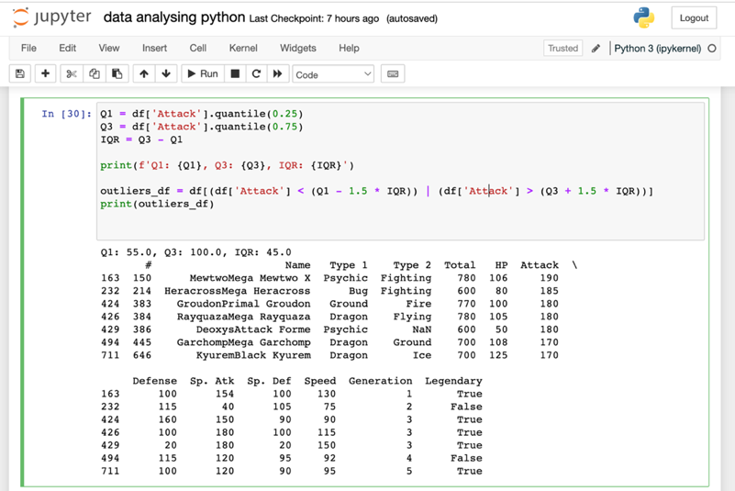

Figure 28 Code to check for outliers

Using “group by”. The output shows the data grouped by the 'Type 1' column, with the group name printed first followed by the first few rows of each group. This can be useful for getting an overview of how the data is distributed within each group and identifying patterns or trends within each group.

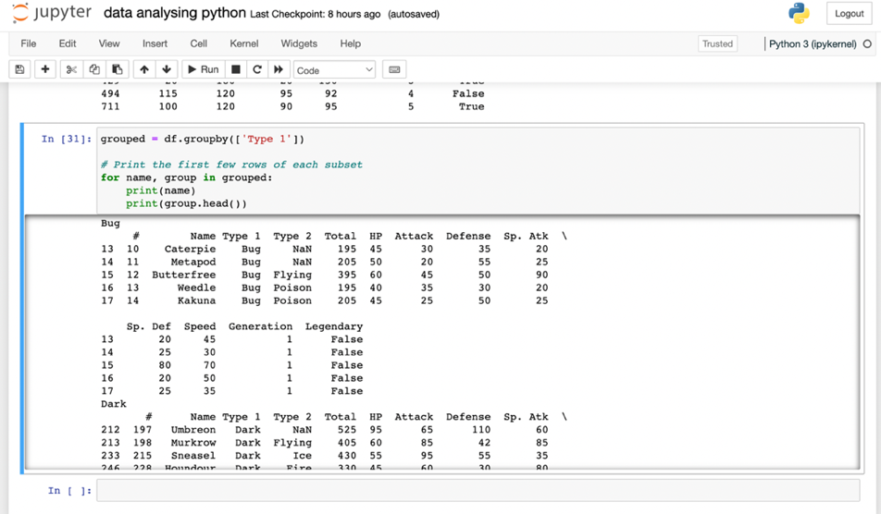

Figure 29 Group by

Calculating the mean, median and standard deviation

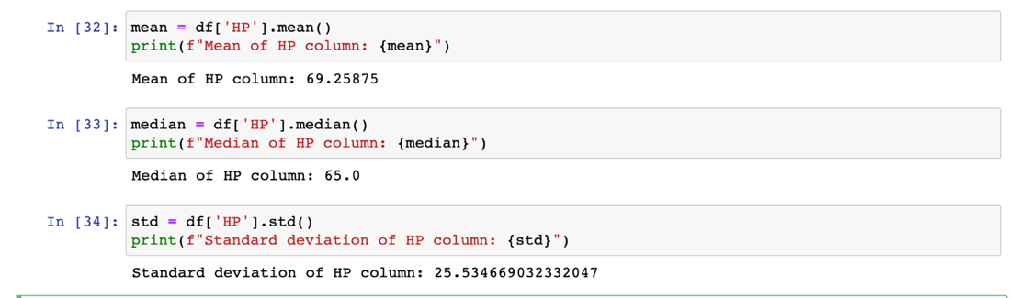

Figure 30 Mean, Median, Standard deviation in Python

Creating a pivot table and calculating the count of individuals in each group.

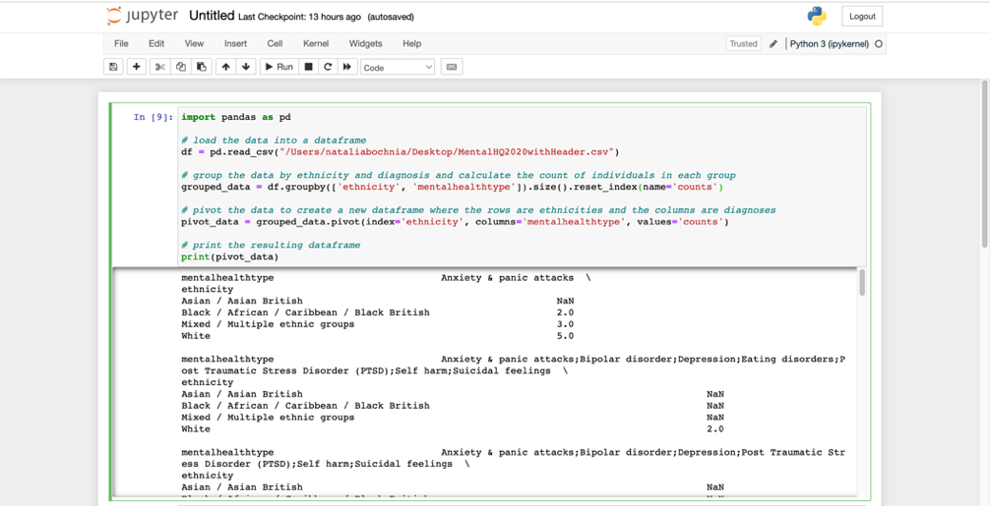

Figure 31 Pivot Table

Next, I will use a Mental Health Services Data Set to demonstrate working with medical data. First, I create a bar chart to show what is the distribution and of mental health diagnoses among different ethnicities including marital status as a factor. We can observe that the "Black, African, Caribbean and Black British Group" has the highest rate of mental health diagnoses, while the "Asian and Asian British Group" has the lowest rate of diagnoses.

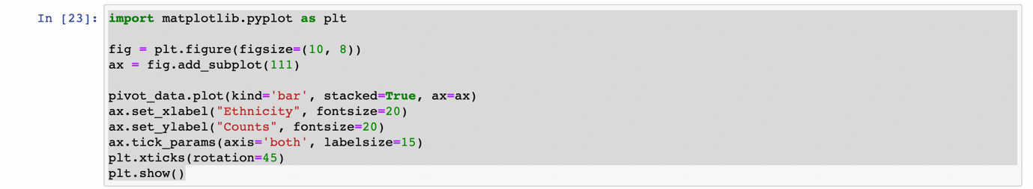

Figure 32 Code for Mental Health Bar Chart

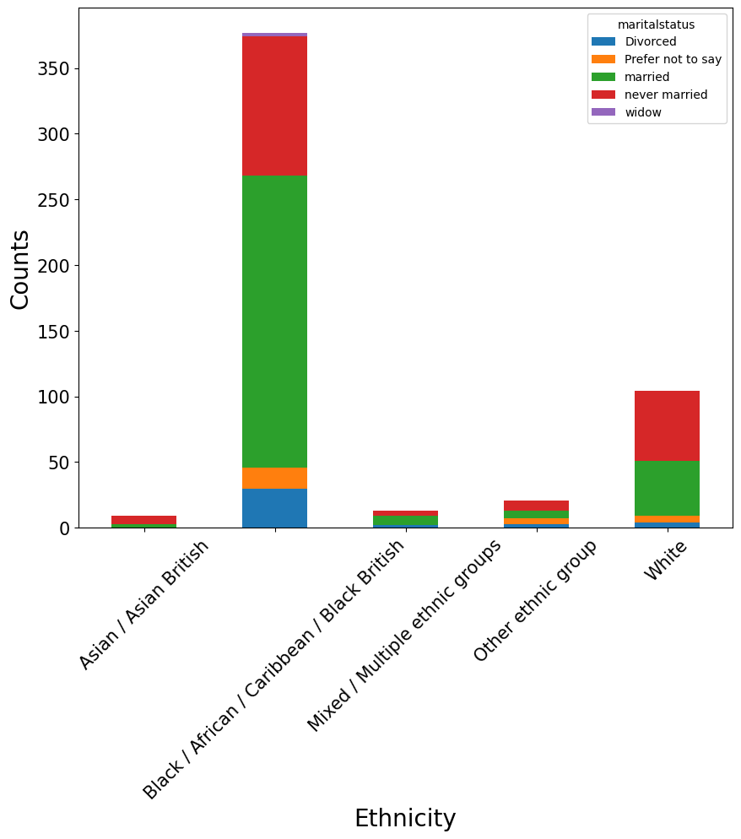

Figure 33 Mental Health Bar Chart

# APPENDIX D Data interpretation and visualization in Tableau

Working with different type of charts as well as geographical visualisation. Analysing data set “Global Mobility Report” from Google.

I upload a cleaned data set to Tableau and select a geographical visualisation. To make it easier to work later, I group Countries to Continents. I decided to combine Asia, Australia and Oceania as a one because they had the least amount of data

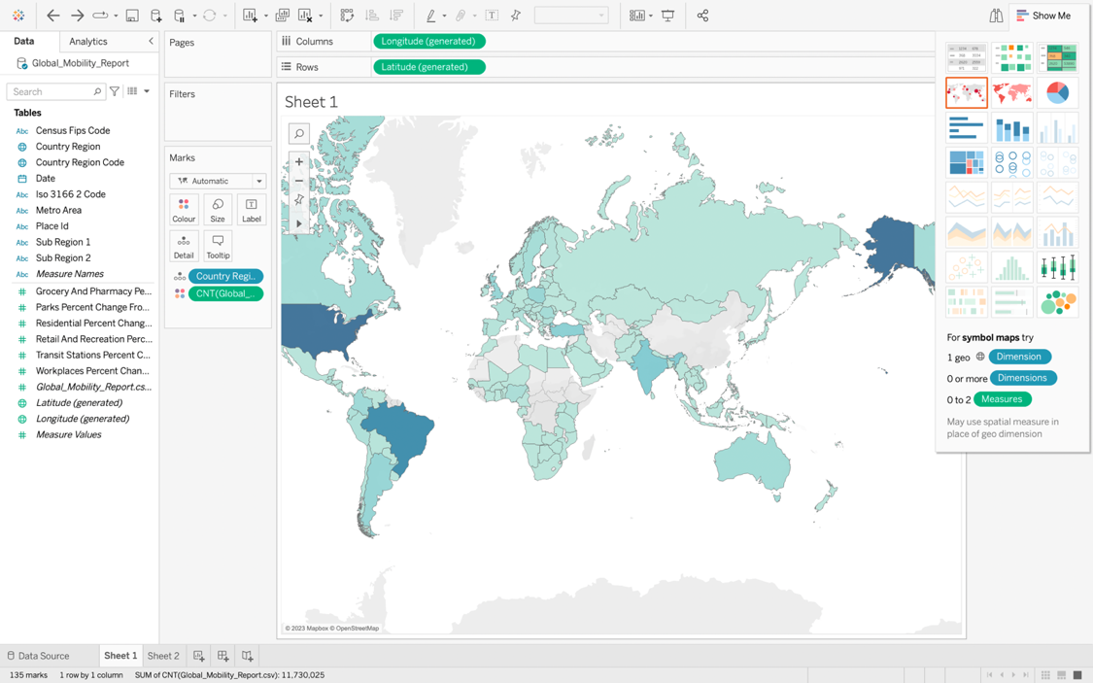

Figure 34 Map

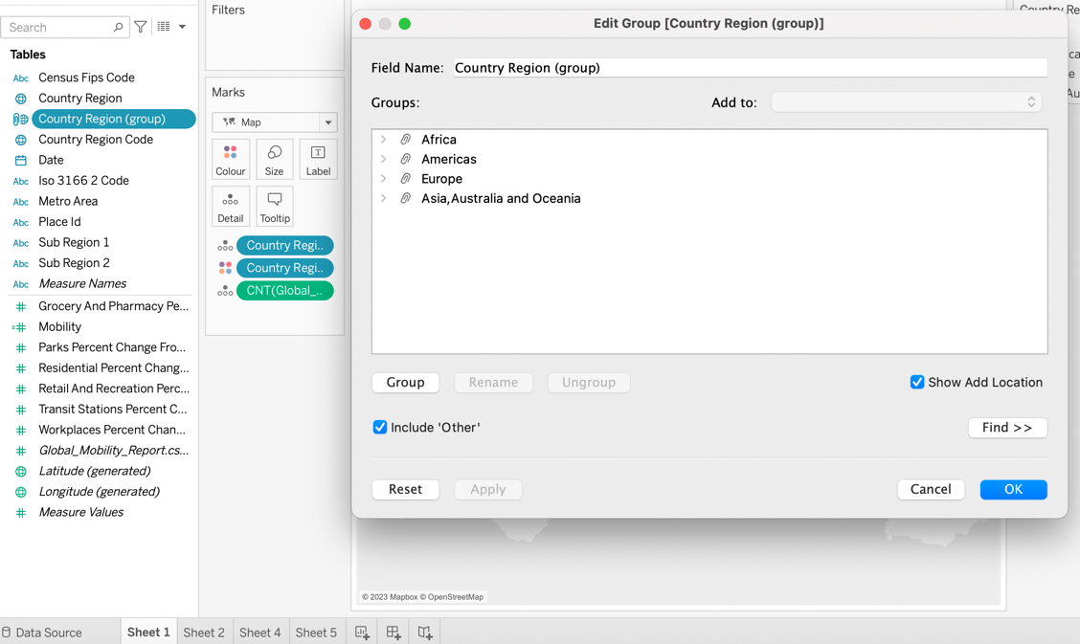

Figure 35 Creating a groups

Then, I select number format as a percentage and create a calculated field to make a percentage smaller and easier to read.

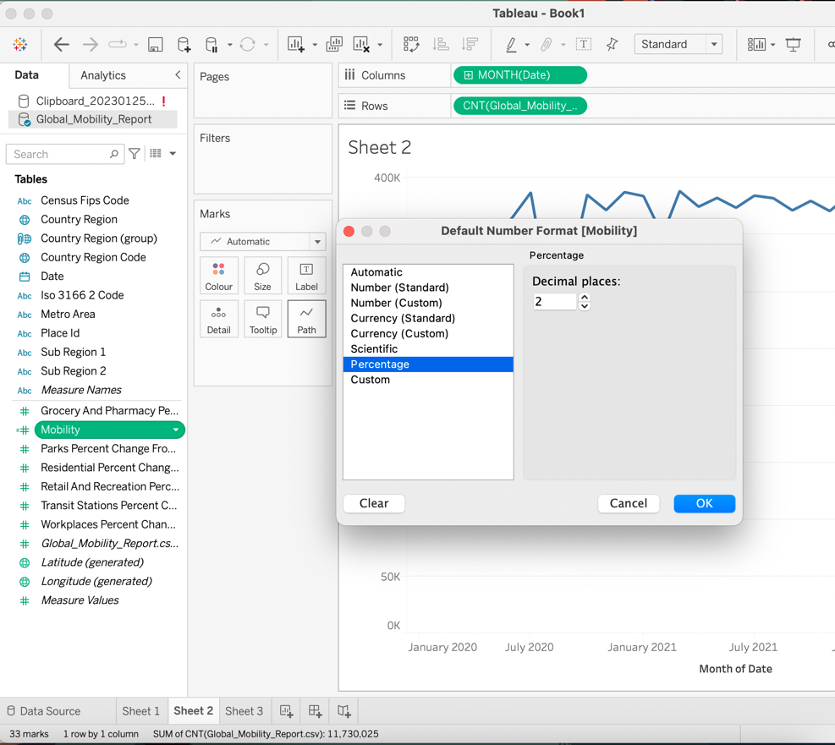

Figure 36 Default Number Format

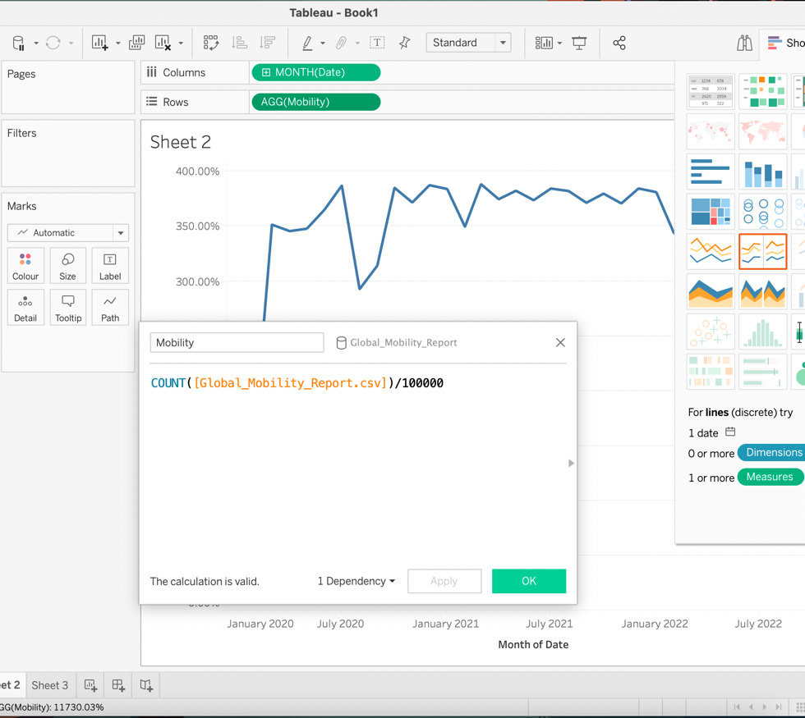

Figure 37 Calculated Field

This is a weekly mobility line chart. We can see that the world peak of mobility during Covid last around 10 weeks and it was from week 23 to week 32.

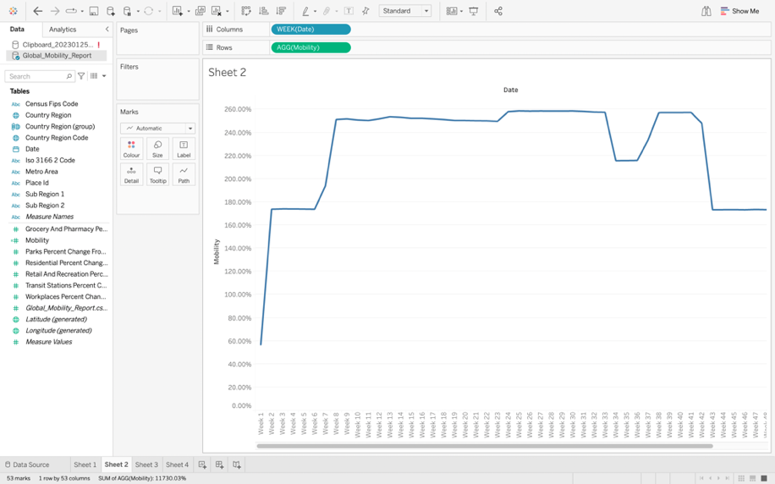

Figure 38 Weekly Mobility Line Chart

This is a monthly mobility chart grouped by Continents. We can see that the biggest mobility was in America and the least in Africa. The biggest peak in all countries was in July 2020.

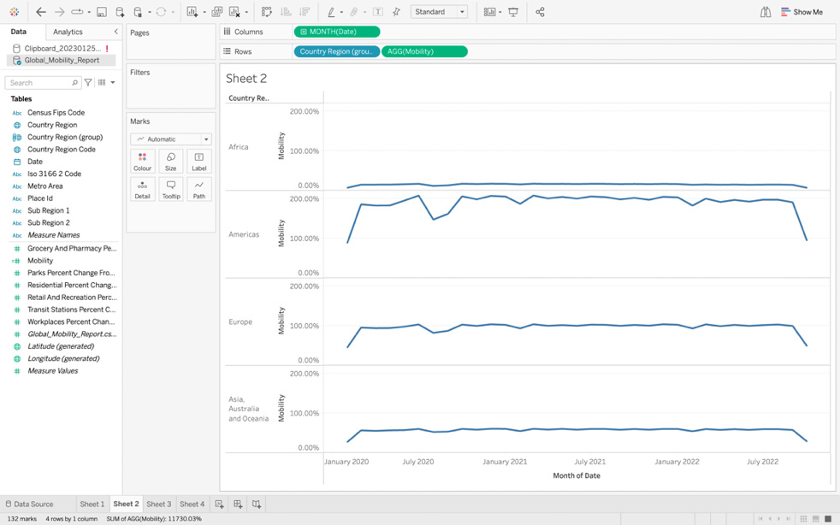

Figure 39 Monthly Mobility Line Chart

Next, I create a map and change colors to have only 4 steps as I only have 4 groups.

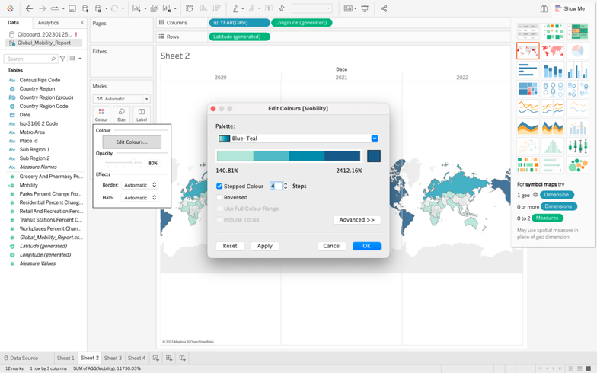

Figure 40 Selecting proper colours

I select a monthly visualization, and this is a result.

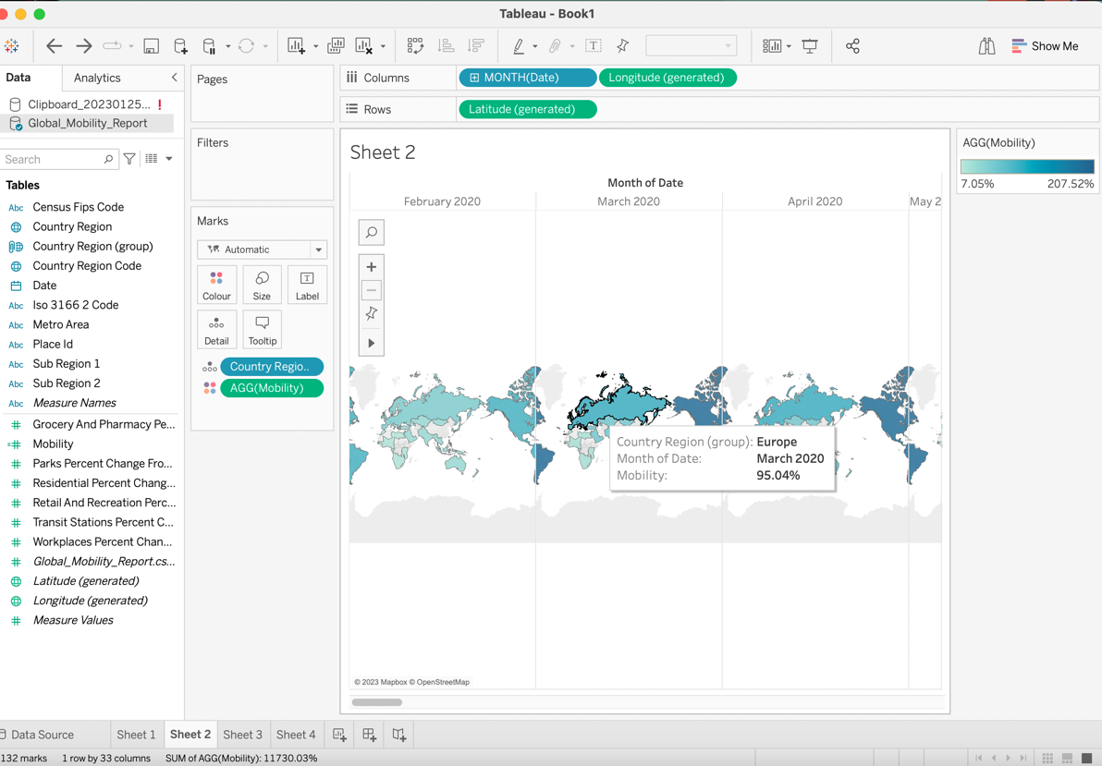

Figure 41 Map 2

After that, I select only Europe from my group, and I add Country Region Code to demonstrate a yearly mobility in each country in Europe. We can see that the biggest mobility was in Poland and UK in 2020.

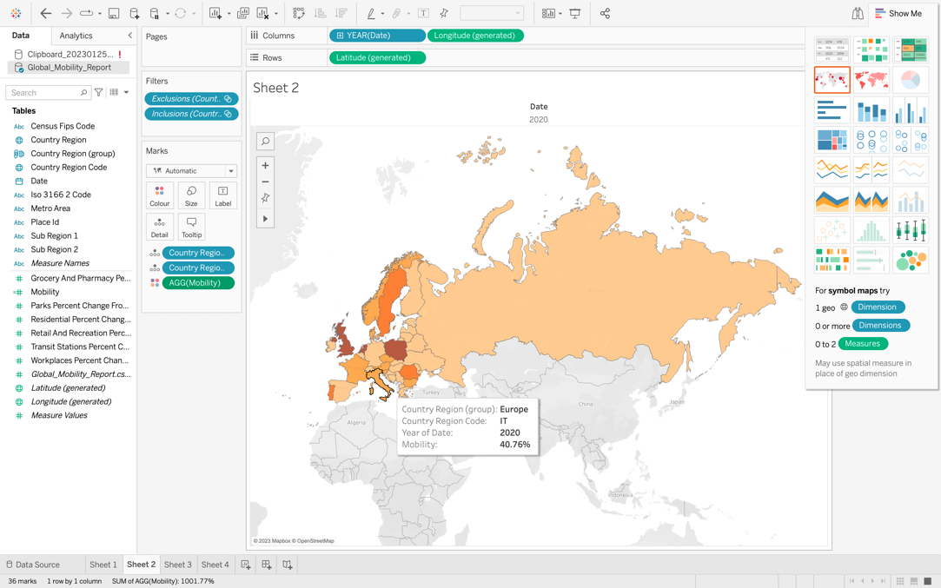

Figure 42 Map of Europe

Next, I choose horizontal bars to show a yearly residential change in each of this continent. We can observe that the biggest change was in America in 2020 and the least in Africa in 2021.

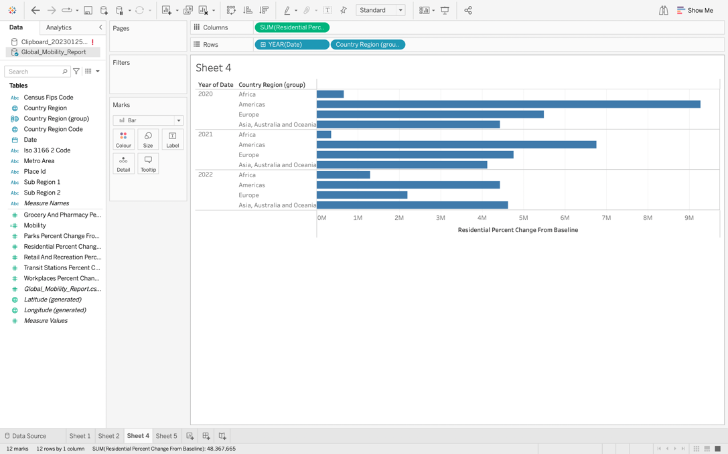

Figure 43 Residential Change Horizontal Bars

I select following side by side bar chart and change the colours to highlight the differences even more. Then, I label bars.

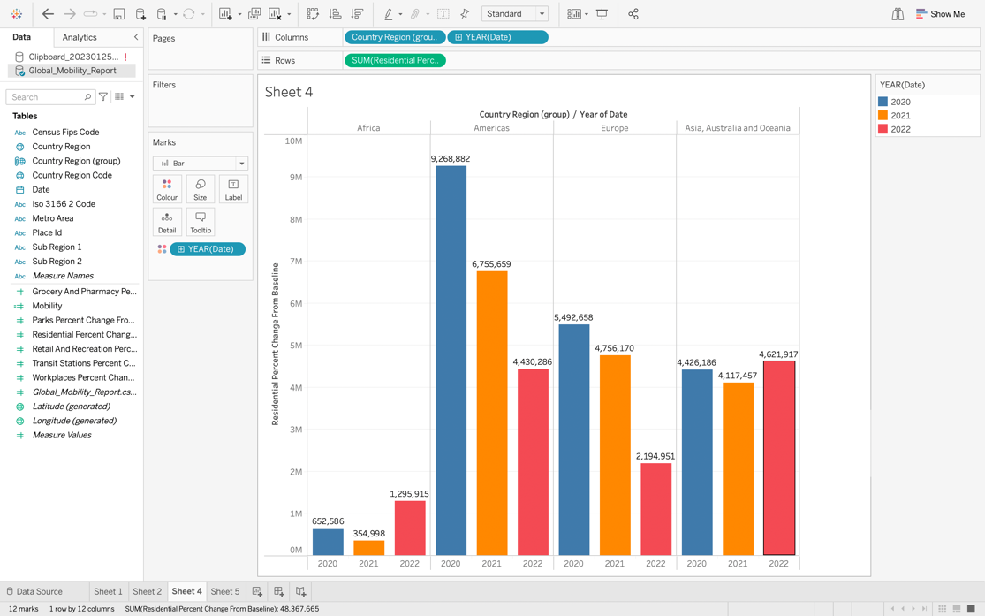

Figure 44 Residential Change Side by Side Bar Chart